**Table 1.** Ground beetle species collected via unbaited pitfall traps at Powdermill Nature Reserve in Rector, Westmoreland County, Pennsylvania, U.S.A. in 2013-2015. The species list is arranged phylogenetically following Bousquet (2012). Vouchers were deposited at the C. A. Triplehorn Insect Collection, Museum of Biological Diversity, The Ohio State University, Columbus, Ohio. Each voucher specimen received a unique identifier number.

|  |  |  |  |  |  |  |  |
| --- | --- | --- | --- | --- | --- | --- | --- |
| **Tribe** | **Species** | **Dispersal** | **2013** | **2014** | **2015** | **Total** | **Identifier Label** |
| Notiophilini | *Notiophilus aeneus* (Herbst) | M | 4 | 11 | 10 | 25 | OSUC 678043-58 |
| Cychrini | *Sphaeroderus canadensis canadensis* Chaudoir | B | 1 | 3 | 8 | 12 | OSUC 672270-311; 672316-20 |
|  | *Sphaeroderus stenostomus lecontei* Dejean | B | 56 | 97 | 74 | 227 | OSUC 677469-569 |
|  | *Scaphinotus* (*Irichroa*) *viduus* (Dejean) | B | 1 | 1 | 4 | 6 | OSUC 671902-9 |
|  | *Scaphinotus* (*Maronetus*) *imperfectus* (Horn) | B | 0 | 5 | 2 | 7 | OSUC 672852-9 |
|  | *Scaphinotus* (*Steniridia*) *andrewsii mutabilis* (Casey) | B | 0 | 0 | 1 | 1 | OSUC 671898-901 |
| Carabini | *Carabus* (*Carabus*) *goryi* Dejean | B | 160 | 233 | 302 | 695 | OSUC 671911-2031 |
| Trechini | *Trechus* (*Trechus*) *quadristriatus* (Schrank) | M | 1 | 0 | 0 | 1 | OSUC 668394 |
| Bembidiini | *Bembidion* (*Eupetedromus*) *graciliforme* Hayward | M | 0 | 0 | 2 | 2 | OSUC 671691-2 |
| Patrobini | *Patrobus longicornis* (Say) | D | 0 | 2 | 0 | 2 | OSUC 671668 |
| Abacetini | *Loxandrus* spp. | M | 0 | 1 | 3 | 4 | OSUC 671687-90 |
| Pterostichini | *Poecilus* (*Poecilus*) *lucublandus* (Say) | M | 28 | 1 | 3 | 32 | OSUC 672434-48 |
|  | *Lophoglossus scrutator* (LeConte) | M | 0 | 3 | 1 | 4 | OSUC 671717-21 |
|  | *Gastrellarius honestus* (Say) | B | 3 | 0 | 3 | 6 | OSUC 668446-52 |
|  | *Myas* (*Trigonognatha*) *coracinus* (Say) | B | 10 | 6 | 0 | 16 | OSUC 672618-32 |
|  | *Myas* (*Trigonognatha*) *cyanescens* Dejean | B | 7 | 4 | 1 | 12 | OSUC 671722-30 |
|  | *Pterostichus* (*Bothriopterus*) *mutus* (Say) | M | 0 | 1 | 3 | 4 | OSUC 671801-5 |
|  | *Pterostichus* (*Bothriopterus*) *trinarius* (Casey) | M | 0 | 2 | 9 | 11 | OSUC 668397-405 |
|  | *Pterostichus* (*Gastrosticta*) *sayanus* Csiki | B | 0 | 3 | 4 | 7 | OSUC 667852-62 |
|  | *Pterostichus* (*Euferonia*) *coracinus* (Newman) | B | 1 | 7 | 1 | 9 | OSUC 672590-614 |
|  | *Pterostichus* (*Euferonia*) *lachrymosus* (Newman) | B | 49 | 77 | 52 | 178 | OSUC 677787-880 |
|  | *Pterostichus* (*Euferonia*) *stygicus* (Say) | B | 75 | 210 | 89 | 374 | OSUC 672036-110 |
|  | *Pterostichus* (*Abacidus*) *atratus* (Newman) | B | 33 | 6 | 1 | 40 | OSUC 668428-43 |
|  | *Pterostichus* (*Abacidus*) *hamiltoni* Horn | B | 41 | 45 | 7 | 93 | OSUC 677965-97 |
|  | *Pterostichus* (*Eosteropus*) *moestus* (Say) | B | 46 | 41 | 60 | 147 | OSUC 677574-694 |
|  | *Pterostichus* (*Monoferonia*) *diligendus* (Chaudoir) | B | 8 | 22 | 5 | 35 | OSUC 672410-29 |
|  | *Pterostichus* (*Cylindrocharis*) *rostratus* (Newman) | B | 15 | 3 | 9 | 27 | OSUC 677885-942 |
|  | *Pterostichus* (*Hypherpes*) *adoxus* (Say) | B | 93 | 90 | 76 | 259 | OSUC 671812-91 |
|  | *Pterostichus* (*Hypherpes*) *tristis* (Dejean) | B | 34 | 19 | 7 | 60 | OSUC 672117-63 |
|  | *Cyclotrachelus* (*Cyclotrachelus*) *fucatus* (Freitag) | B | 127 | 141 | 103 | 371 | OSUC 672668-746 |
|  | *Cyclotrachelus* (*Evarthrus*) *sigillatus* (Say) | B | 113 | 139 | 81 | 333 | OSUC 672468-581 |
|  | *Cyclotrachelus* (*Evarthrus*) *sodalis sodalis* (LeConte) | B | 37 | 37 | 14 | 88 | OSUC 678000-10; 678013-40 |
| Chlaeniini | *Chlaenius* (*Anomoglossus*) *emarginatus* Say | M | 97 | 125 | 143 | 365 | OSUC 672169-263 |
| Licinini | *Dicaelus* (*Paradicaelus*) *politus* Dejean | B | 4 | 11 | 25 | 40 | OSUC 671338-84 |
|  | *Dicaelus* (*Paradicaelus*) *sculptilis intricatus* LeConte | B | 6 | 11 | 18 | 35 | OSUC 672829-49; 672451-7 |
|  | *Dicaelus* (*Paradicaelus*) *teter* Bonelli | B | 40 | 79 | 77 | 196 | OSUC 677699-782 |
| Harpalini | *Notiobia* (*Anisotarsus*) *nitidipennis* (LeConte) | M | 2 | 2 | 4 | 8 | OSUC 672651-65 |
|  | *Notiobia* (*Anisotarsus*) *terminata* (Say) | M | 1 | 2 | 0 | 3 | OSUC 668408-12 |
|  | *Xestonotus lugubris* (Dejean) | M | 1 | 0 | 0 | 1 | OSUC 671670 |
|  | *Anisodactylus* (*Anisodactylus*) *agricola* (Say) | B | 0 | 0 | 1 | 1 | OSUC 671681 |
|  | *Amphasia* (*Amphasia*) *interstitialis* (Say) | M | 15 | 2 | 26 | 43 | OSUC 671046-86 |
|  | *Harpalus* (*Opadius*) *spadiceus* Dejean | B | 0 | 0 | 1 | 1 | OSUC 671685-6 |
|  | *Selenophorus* (*Selenophorus*) *opalinus* (LeConte) | M | 0 | 0 | 1 | 1 | OSUC 671684 |
|  | *Trichotichnus* (*Trichotichnus*) *vulpeculus* (Say) | M | 1 | 2 | 0 | 3 | OSUC 671676-8 |
|  | *Trichotichnus* (*Iridessus*) *autumnalis* (Say) | M | 7 | 22 | 77 | 106 | OSUC 671091-144 |
| Sphodrini | *Calathus* (*Neocalathus*) *gregarius* (Say) | D | 2 | 0 | 0 | 2 | OSUC 671669 |
|  | *Synuchus impunctatus* (Say) | D | 1 | 10 | 2 | 13 | OSUC 671710-6 |
| Platynini | *Olisthopus parmatus* (Say) | M | 2 | 5 | 5 | 12 | OSUC 672754-65 |
|  | *Agonum* (*Europhilus*) *retractum* LeConte | D | 0 | 0 | 2 | 2 | OSUC 671696-8 |
|  | *Agonum* (*Olisares*) *excavatum* Dejean | M | 1 | 0 | 0 | 1 | NAa |
|  | *Agonum* (*Olisares*) *ferreum* Haldeman | M | 6 | 3 | 1 | 10 | OSUC 671700-5 |
|  | *Agonum* (*Olisares*) *fidele* Casey | M | 9 | 67 | 21 | 97 | OSUC 671389-427 |
|  | *Platynus* (*Platynus*) *decentis* (Say) | B | 4 | 3 | 6 | 13 | OSUC 668453-62 |
|  | *Platynus* (*Platynus*) *tenuicollis* (LeConte) | M | 39 | 20 | 7 | 66 | OSUC 671747-83 |
|  | *Platynus* (*Batenus*) *angustatus* Dejean | B | 176 | 270 | 17 | 463 | OSUC 672323-401 |
|  | *Platynus* (*Batenus*) *hypolithos* (Say) | B | 11 | 36 | 1 | 48 | OSUC 672768-97 |
| Lebiini | *Cymindis* (*Tarulus*) *americana* Dejean | D | 0 | 1 | 0 | 1 | OSUC 671667 |
|  | *Cymindis* (*Pinacodera*) *limbata* Dejean | M | 1 | 1 | 0 | 2 | OSUC 671665-6 |
|  | *Apenes* (*Apenes*) *lucidula* (Dejean | D | 6 | 12 | 1 | 19 | OSUC 668413-26 |
|  | **Total Number of Individuals** |  | **1375** | **1894** | **1371** | **4640** |  |
|  | **Total Number of Species** |  | **45** | **48** | **49** | **59** |  |

aNo vouchers deposited

**Table.** Main effects of canopy gap formation and understory vegetation removal treatments on total ground beetle activity-abundance, species richness, evenness and diversity (mean ± SE) in 2013-2015 in forests at Powdermill Nature Reserve, Rector, Pennsylvania, USA. Results are given for the repeated measures ANOVA. Significant (α ≤ 0.05) *P* values are shown in bold.

|  |  |  |  |  |  |  |  |  |  |  |  |  |  |  |  |  |  |
| --- | --- | --- | --- | --- | --- | --- | --- | --- | --- | --- | --- | --- | --- | --- | --- | --- | --- |
|  |  |  | Canopy Disturbance | | | |  | Understory Vegetation Disturbance | | | |  | Gap × Veg | |  | 2013 Covariate | |
| Invertebrate Index | Year | df | Canopy Gap | Closed Canopy | F | *P* |  | Vegetation  Removed | Vegetation  Undisturbed | F | *P* |  | F | *P* |  | F | *P* |
| Activity-Abundance | 2013 | 1,16 | 6.5 ± 0.8 | 6.2 ± 0.5 | 0.03 | 0.864 |  | 6.9 ± 0.8 | 6.0 ± 0.5 | 0.07 | 0.795 |  | 0.02 | 0.881 |  | na | na |
|  | 2014 | 1,20 | 11.2 ± 1.4 | 8.1 ± 0.8 | 2.77 | 0.111 |  | 10.2 ± 1.2 | 8.7 ± 0.9 | 0.04 | 0.839 |  | 0.17 | 0.688 |  | 4.74 | **0.038** |
|  | 2015 | 1,20 | 6.7 ± 0.9 | 6.3 ± 0.7 | 0.87 | 0.361 |  | 7.6 ± 1.2 | 5.9 ± 0.6 | 0.75 | 0.395 |  | 0.22 | 0.642 |  | 0.77 | 0.389 |
|  |  |  |  |  |  |  |  |  |  |  |  |  |  |  |  |  |  |
| Species Richness | 2013 | 1,16 | 3.5 ± 0.3 | 3.2 ± 0.2 | 0.00 | 0.998 |  | 3.5 ± 0.3 | 3.2 ± 0.2 | 0.03 | 0.854 |  | 0.00 | 0.963 |  | na | na |
|  | 2014 | 1,20 | 4.2 ± 0.3 | 3.6 ± 0.2 | 2.39 | 0.138 |  | 4.0 ± 0.3 | 3.73 ± 0.2 | 0.00 | 0.951 |  | 0.11 | 0.738 |  | 5.10 | **0.032** |
|  | 2015 | 1,20 | 3.4 ± 0.3 | 3.0 ± 0.2 | 3.09 | 0.094 |  | 3.6 ± 0.3 | 2.9 ± 0.2 | 1.98 | 0.174 |  | 0.34 | 0.566 |  | 1.14 | 0.298 |
|  |  |  |  |  |  |  |  |  |  |  |  |  |  |  |  |  |  |
| Evenness | 2013 | 1,16 | 0.646 ± 0.04 | 0.652 ± 0.03 | 0.00 | 0.945 |  | 0.616 ± 0.04 | 0.670 ± 0.03 | 0.24 | 0.630 |  | 0.62 | 0.441 |  | na | na |
|  | 2014 | 1,20 | 0.710 ± 0.02 | 0.680 ± 0.03 | 0.05 | 0.823 |  | 0.667 ± 0.04 | 0.753 ± 0.04 | 4.43 | **0.048** |  | 2.22 | 0.152 |  | 0.30 | 0.590 |
|  | 2015 | 1,20 | 0.718 ± 0.04 | 0.627 ± 0.03 | 4.42 | **0.045** |  | 0.668 ± 0.05 | 0.652 ± 0.04 | 2.67 | 0.118 |  | 0.06 | 0.804 |  | 1.52 | 0.228 |
|  |  |  |  |  |  |  |  |  |  |  |  |  |  |  |  |  |  |
| Shannon Diversity | 2013 | 1,16 | 0.910 ± 0.07 | 0.832 ± 0.05 | 0.04 | 0.841 |  | 0.870 ± 0.07 | 0.857 ± 0.05 | 0.01 | 0.933 |  | 0.00 | 0.949 |  | na | na |
|  | 2014 | 1,20 | 1.084 ± 0.07 | 0.946 ± 0.06 | 1.50 | 0.234 |  | 0.994 ± 0.08 | 1.001 ± 0.06 | 0.06 | 0.809 |  | 0.30 | 0.587 |  | 5.21 | **0.030** |
|  | 2015 | 1,20 | 0.967 ± 0.07 | 0.808 ± 0.05 | 4.78 | **0.037** |  | 0.954 ± 0.08 | 0.814 ± 0.05 | 2.67 | 0.118 |  | 0.40 | 0.534 |  | 0.07 | 0.800 |
|  |  |  |  |  |  |  |  |  |  |  |  |  |  |  |  |  |  |
| Simpson Diversity | 2013 | 1,16 | 0.471 ± 0.03 | 0.449 ± 0.02 | 0.20 | 0.659 |  | 0.448 ± 0.04 | 0.463 ± 0.03 | 0.00 | 0.946 |  | 0.13 | 0.725 |  | na | na |
|  | 2014 | 1,20 | 0.557 ± 0.03 | 0.492 ± 0.02 | 1.44 | 0.243 |  | 0.508 ± 0.04 | 0.523 ± 0.03 | 0.22 | 0.641 |  | 0.58 | 0.454 |  | 5.34 | **0.029** |
|  | 2015 | 1,20 | 0.514 ± 0.03 | 0.437 ± 0.02 | 5.40 | **0.028** |  | 0.496 ± 0.04 | 0.447 ± 0.03 | 1.37 | 0.256 |  | 0.10 | 0.757 |  | 1.26 | 0.275 |

**Table.** Main effects of canopy gap formation and understory vegetation removal treatments on the activity-abundance (mean ± SE) of the ten most common ground beetle species in 2013-2015 in forests at Powdermill Nature Reserve, Rector, Pennsylvania, USA. Results are given for the repeated measures ANOVA. Significant (α ≤ 0.05) *P* values are shown in bold.

|  |  |  |  |  |  |  |  |  |  |  |  |  |  |  |  |  |  |
| --- | --- | --- | --- | --- | --- | --- | --- | --- | --- | --- | --- | --- | --- | --- | --- | --- | --- |
|  |  |  | Canopy Disturbance | | | |  | Understory Vegetation Disturbance | | | |  | Gap × Veg | |  | 2013 Covariate | |
| Species | Year | df | Canopy Gap | Closed Canopy | F | *P* |  | Vegetation  Removed | Vegetation  Undisturbed | F | *P* |  | F | *P* |  | F | *P* |
| *Carabus goryi* | 2013 | 1,16 | 0.7 ± 0.2 | 0.8 ± 0.1 | 0.73 | 0.404 |  | 0.9 ± 0.2 | 0.6 ± 0.1 | 0.05 | 0.820 |  | 1.32 | 0.267 |  | na | na |
|  | 2014 | 1,20 | 1.0 ± 0.2 | 1.2 ± 0.2 | 0.09 | 0.762 |  | 2.1 ± 0.3 | 0.7 ± 0.1 | 4.39 | **0.045** |  | 1.17 | 0.292 |  | 2.79 | 0.106 |
|  | 2015 | 1,20 | 1.2 ± 0.2 | 1.6 ± 0.3 | 0.01 | 0.943 |  | 2.1 ± 0.4 | 1.0 ± 0.2 | 7.33 | **0.013** |  | 0.00 | 0.958 |  | 1.46 | 0.237 |
|  |  |  |  |  |  |  |  |  |  |  |  |  |  |  |  |  |  |
| *Chlaenius emarginatus* | 2013 | 1,16 | 0.7 ± 0.2 | 0.3 ± 0.2 | 2.28 | 0.082 |  | 0.3 ± 0.1 | 0.5 ± 0.1 | 0.00 | 0.958 |  | 1.61 | 0.222 |  | na | na |
|  | 2014 | 1,20 | 0.8 ± 0.2 | 0.4 ± 0.1 | 0.76 | 0.395 |  | 0.8 ± 0.2 | 0.4 ± 0.1 | 3.08 | 0.091 |  | 0.28 | 0.603 |  | 5.76 | **0.023** |
|  | 2015 | 1,20 | 1.1 ± 0.3 | 0.5 ± 0.1 | 7.36 | **0.013** |  | 1.0 ± 0.3 | 0.6 ± 0.1 | 3.08 | 0.093 |  | 0.92 | 0.347 |  | 0.21 | 0.652 |
|  |  |  |  |  |  |  |  |  |  |  |  |  |  |  |  |  |  |
| *Cyclotrachelus fucatus* | 2013 | 1,16 | 0.3 ± 0.2 | 0.7 ± 0.2 | 0.88 | 0.363 |  | 0.5 ± 0.2 | 0.6 ± 0.1 | 0.21 | 0.652 |  | 0.00 | 0.967 |  | na | na |
|  | 2014 | 1,20 | 0.3 ± 0.1 | 0.7 ± 0.2 | 0.48 | 0.496 |  | 0.2 ± 0.1 | 0.7 ± 0.2 | 1.20 | 0.284 |  | 2.82 | 0.105 |  | 4.98 | **0.034** |
|  | 2015 | 1,20 | 0.3 ± 0.1 | 0.6 ± 0.1 | 0.63 | 0.434 |  | 0.4 ± 0.1 | 0.6 ± 0.1 | 0.38 | 0.545 |  | 2.84 | 0.103 |  | 3.48 | 0.076 |
|  |  |  |  |  |  |  |  |  |  |  |  |  |  |  |  |  |  |
| *Cyclotrachelus sigillatus* | 2013 | 1,16 | 0.3 ± 0.1 | 0.6 ± 0.2 | 1.44 | 0.247 |  | 0.2 ± 0.1 | 0.7 ± 0.2 | 0.01 | 0.912 |  | 0.40 | 0.537 |  | na | na |
|  | 2014 | 1,20 | 0.5 ± 0.1 | 0.8 ± 0.3 | 0.69 | 0.414 |  | 0.4 ± 0.1 | 0.9 ± 0.3 | 0.08 | 0.783 |  | 6.22 | **0.019** |  | 3.03 | 0.093 |
|  | 2015 | 1,20 | 0.6 ± 0.1 | 0.3 ± 0.1 | 4.19 | **0.050** |  | 0.4 ± 0.1 | 0.4 ± 0.1 | 0.43 | 0.521 |  | 2.30 | 0.144 |  | 7.57 | **0.012** |
|  |  |  |  |  |  |  |  |  |  |  |  |  |  |  |  |  |  |
| *Dicaelus teter* | 2013 | 1,16 | 0.2 ± 0.1 | 0.2 ± 0.04 | 2.00 | 0.176 |  | 0.1 ± 0.04 | 0.2 ± 0.1 | 0.01 | 0.920 |  | 2.27 | 0.151 |  | na | na |
|  | 2014 | 1,20 | 0.4 ± 0.1 | 0.4 ± 0.1 | 0.20 | 0.661 |  | 0.4 ± 0.1 | 0.4 ± 0.1 | 0.40 | 0.535 |  | 4.10 | **0.053** |  | 4.86 | **0.036** |
|  | 2015 | 1,20 | 0.2 ± 0.1 | 0.4 ± 0.1 | 5.38 | **0.028** |  | 0.5 ± 0.1 | 0.3 ± 0.1 | 4.41 | **0.048** |  | 2.78 | 0.107 |  | 4.21 | **0.050** |
|  |  |  |  |  |  |  |  |  |  |  |  |  |  |  |  |  |  |
| *Platynus angustatus* | 2013 | 1,16 | 0.7 ± 0.2 | 0.9 ± 0.2 | 0.00 | 0.994 |  | 0.9 ± 0.2 | 0.7 ± 0.1 | 0.00 | 0.955 |  | 0.15 | 0.699 |  | na | na |
|  | 2014 | 1,20 | 2.1 ± 0.4 | 1.0 ± 0.2 | 10.85 | **0.003** |  | 2.1 ± 0.4 | 1.0 ± 0.2 | 3.08 | 0.088 |  | 5.44 | **0.029** |  | 0.11 | 0.744 |
|  | 2015 | 1,20 | 0.1 ± 0.05 | 0.1 ± 0.02 | 1.39 | 0.252 |  | 0.1 ± 0.04 | 0.1 ± 0.03 | 0.26 | 0.616 |  | 11.9 | **0.001** |  | 4.87 | **0.036** |
|  |  |  |  |  |  |  |  |  |  |  |  |  |  |  |  |  |  |
| *Pterostichus adoxus* | 2013 | 1,16 | 0.4 ± 0.1 | 0.4 ± 0.1 | 0.02 | 0.900 |  | 0.4 ± 0.1 | 0.4 ± 0.1 | 0.63 | 0.438 |  | 1.46 | 0.199 |  | na | na |
|  | 2014 | 1,20 | 0.6 ± 0.2 | 0.4 ± 0.1 | 0.30 | 0.589 |  | 0.7 ± 0.2 | 0.3 ± 0.1 | 0.14 | 0.710 |  | 0.26 | 0.614 |  | 0.64 | 0.431 |
|  | 2015 | 1,20 | 0.3 ± 0.1 | 0.4 ± 0.1 | 0.08 | 0.786 |  | 0.4 ± 0.1 | 0.3 ± 0.1 | 0.01 | 0.932 |  | 0.14 | 0.711 |  | 0.30 | 0.587 |
|  |  |  |  |  |  |  |  |  |  |  |  |  |  |  |  |  |  |
| *Pterostichus lachrymosus* | 2013 | 1,16 | 0.1 ± 0.1 | 0.3 ± 0.1 | 0.43 | 0.522 |  | 0.1 ± 0.1 | 0.3 ± 0.1 | 0.42 | 0.523 |  | 1.18 | 0.253 |  | na | na |
|  | 2014 | 1,20 | 0.3 ± 0.1 | 0.5 ± 0.1 | 3.20 | 0.088 |  | 0.3 ± 0.1 | 0.5 ± 0.1 | 2.55 | 0.125 |  | 6.01 | **0.021** |  | 27.8 | **<0.001** |
|  | 2015 | 1,20 | 0.1 ± 0.03 | 0.2 ± 0.1 | 0.30 | 0.591 |  | 0.1 ± 0.03 | 0.2 ± 0.1 | 1.09 | 0.308 |  | 1.66 | 0.211 |  | 29.0 | **<0.001** |
|  |  |  |  |  |  |  |  |  |  |  |  |  |  |  |  |  |  |
| *Pterostichus stygicus* | 2013 | 1,16 | 0.4 ± 0.1 | 0.3 ± 0.1 | 0.04 | 0.846 |  | 0.4 ± 0.1 | 0.3 ± 0.1 | 0.61 | 0.444 |  | 0.70 | 0.413 |  | na | na |
|  | 2014 | 1,20 | 1.9 ± 0.5 | 0.6 ± 0.2 | 8.84 | **0.006** |  | 0.9 ± 0.3 | 1.2 ± 0.3 | 1.99 | 0.173 |  | 1.79 | 0.196 |  | 34.3 | **<0.001** |
|  | 2015 | 1,20 | 0.9 ± 0.4 | 0.3 ± 0.1 | 1.74 | 0.198 |  | 0.4 ± 0.1 | 0.6 ± 0.2 | 1.62 | 0.217 |  | 7.96 | **0.009** |  | 9.23 | **0.005** |
|  |  |  |  |  |  |  |  |  |  |  |  |  |  |  |  |  |  |
| *Sphaeroderus lecontei* | 2013 | 1,16 | 0.3 ± 0.1 | 0.3 ± 0.1 | 0.31 | 0.585 |  | 0.2 ± 0.1 | 0.3 ± 0.1 | 0.04 | 0.840 |  | 0.08 | 0.784 |  | na | na |
|  | 2014 | 1,20 | 0.5 ± 0.2 | 0.4 ± 0.1 | 0.05 | 0.824 |  | 0.4 ± 0.1 | 0.5 ± 0.1 | 0.71 | 0.409 |  | 2.54 | 0.126 |  | 0.49 | 0.488 |
|  | 2015 | 1,20 | 0.2 ± 0.04 | 0.5 ± 0.1 | 3.65 | 0.067 |  | 0.3 ± 0.1 | 0.4 ± 0.1 | 0.03 | 0.872 |  | 0.01 | 0.915 |  | 7.58 | **0.010** |

**Table.** Ground beetle indicator species and Spearman rank correlation coefficients for canopy gap and understory vegetation disturbance treatments in 2013-2015 at Powdermill Nature Reserve, Rector, Pennsylvania, USA. *P* values for the indicator species analyses were generated through Monte Carlo permutation tests.

|  |  |  |  |  |  |  |  |  |  |  |
| --- | --- | --- | --- | --- | --- | --- | --- | --- | --- | --- |
| Indicator Species | Year | Treatment | Observed Indicator Value (IV) |  | IV from Randomized Groups | | |  | Correlation | |
|  | Mean | Standard Deviation | *P* |  | *r2* | *P* |
| *Agonum fidele* | 2014 | Understory Undisturbed | 7.5 |  | 4.4 | 1.47 | 0.041 |  | 0.25 | **<0.001** |
|  | 2015 | Understory Undisturbed | 6.2 |  | 3.6 | 1.27 | 0.062 |  | 0.29 | **<0.001** |
|  | 2015 | Canopy Gap | 6.6 |  | 3.5 | 1.18 | 0.017 |  | 0.18 | **0.012** |
| *Carabus goryi* | 2014 | Understory Removed | 38.2 |  | 22.8 | 3.05 | 0.001 |  | -0.16 | **0.026** |
|  | 2015 | Understory Removed | 39.5 |  | 27.2 | 3.41 | 0.004 |  | -0.10 | 0.084 |
| *Chlaenius emarginatus* | 2015 | Canopy Gap | 26.8 |  | 14.3 | 2.66 | 0.001 |  | 0.23 | **0.001** |
|  | 2015 | Understory Removed | 21.9 |  | 14.3 | 2.54 | 0.010 |  | 0.20 | **0.005** |
| *Cyclotrachelus fucatus* | 2014 | Closed Canopy | 23.2 |  | 16.9 | 2.80 | 0.028 |  | -0.08 | 0.447 |
|  | 2014 | Understory Undisturbed | 25.0 |  | 17.1 | 3.05 | 0.021 |  | 0.22 | **0.001** |
| *Cyclotrachelus sigillatus* | 2014 | Understory Undisturbed | 19.8 |  | 13.8 | 2.34 | 0.027 |  | 0.32 | **<0.001** |
|  | 2015 | Canopy Gap | 23.4 |  | 14.1 | 2.29 | 0.003 |  | 0.14 | **0.043** |
| *Cyclotrachelus sodalis* | 2014 | Canopy Gap | 14.8 |  | 6.1 | 1.68 | 0.001 |  | 0.06 | 0.346 |
|  | 2015 | Canopy Gap | 6.9 |  | 3.0 | 1.13 | 0.008 |  | 0.20 | **0.004** |
|  | 2014 | Understory Removed | 14.5 |  | 6.2 | 1.73 | 0.001 |  | -0.08 | 0.235 |
|  | 2015 | Understory Removed | 8.0 |  | 2.9 | 1.23 | 0.007 |  | 0.10 | 0.139 |
| *Dicaelus teter* | 2015 | Understory Removed | 17.9 |  | 10.2 | 2.94 | 0.026 |  | -0.17 | **0.015** |
| *Platynus angustatus* | 2014 | Canopy Gap | 34.8 |  | 22.2 | 2.82 | 0.002 |  | 0.28 | **<0.001** |
|  | 2014 | Understory Removed | 32.3 |  | 22.3 | 3.03 | 0.011 |  | -0.05 | 0.413 |
| *Platynus hypolithos* | 2014 | Canopy Gap | 10.3 |  | 4.9 | 1.55 | 0.012 |  | 0.17 | **0.018** |
|  | 2014 | Understory Removed | 14.8 |  | 5.1 | 1.58 | 0.001 |  | -0.02 | 0.728 |
| *Pterostichus adoxus* | 2014 | Canopy Gap | 21.0 |  | 15.1 | 2.40 | 0.024 |  | 0.22 | **0.002** |
|  | 2014 | Understory Removed | 22.7 |  | 15.2 | 2.65 | 0.020 |  | -0.13 | 0.082 |
| *Pterostichus atratus* | 2014 | Understory Removed | 10.8 |  | 3.9 | 1.33 | 0.001 |  | -0.10 | 0.167 |
| *Pterostichus lachrymosus* | 2015 | Closed Canopy | 15.4 |  | 9.3 | 1.92 | 0.008 |  | -0.02 | 0.815 |
|  | 2015 | Understory Undisturbed | 15.0 |  | 9.2 | 1.80 | 0.009 |  | 0.23 | **0.001** |
| *Pterostichus stygicus* | 2014 | Canopy Gap | 30.3 |  | 16.6 | 2.70 | 0.001 |  | 0.16 | **0.031** |
|  | 2015 | Canopy Gap | 17.3 |  | 10.4 | 2.43 | 0.015 |  | 0.14 | 0.057 |
| *Pterostichus tristis* | 2014 | Understory Removed | 8.8 |  | 4.0 | 1.82 | 0.019 |  | -0.24 | **0.001** |
| *Sphaeroderus lecontei* | 2015 | Closed Canopy | 16.9 |  | 12.9 | 2.37 | 0.073 |  | -0.15 | **0.032** |

**Table.** Main effects of canopy gap formation and understory vegetation removal treatments on the activity-abundance (mean ± SE) of macropterous (capable of flight) and brachypterous (incapable of flight) ground beetles in 2013-2015 at Powdermill Nature Reserve, Rector, Pennsylvania, USA. Results are given for the repeated measures ANOVA. Significant (α ≤ 0.05) *P* values are shown in bold.

|  |  |  |  |  |  |  |  |  |  |  |  |  |  |  |  |  |  |
| --- | --- | --- | --- | --- | --- | --- | --- | --- | --- | --- | --- | --- | --- | --- | --- | --- | --- |
|  |  |  | Canopy Disturbance | | | |  | Understory Vegetation Disturbance | | | |  | Gap × Veg | |  | 2013 Covariate | |
| Wing Morphology | Year | df | Canopy Gap | Closed Canopy | F | *P* |  | Vegetation  Removed | Vegetation  Undisturbed | F | *P* |  | F | *P* |  | F | *P* |
| Macropterous | 2013 | 1,16 | 1.3 ± 0.2 | 0.7 ± 0.1 | 0.77 | 0.392 |  | 0.9 ± 0.2 | 0.9 ± 0.1 | 0.16 | 0.694 |  | 0.58 | 0.456 |  | na | na |
|  | 2014 | 1,20 | 1.9 ± 0.6 | 0.7 ± 0.1 | 0.36 | 0.551 |  | 1.1 ± 0.2 | 1.3 ± 0.3 | 0.18 | 0.675 |  | 0.18 | 0.678 |  | 4.91 | **0.035** |
|  | 2015 | 1,20 | 1.8 ± 0.3 | 1.1 ± 0.2 | 7.32 | **0.011** |  | 1.7 ± 0.4 | 1.2 ± 0.2 | 0.02 | 0.898 |  | 0.51 | 0.480 |  | 3.35 | 0.079 |
|  |  |  |  |  |  |  |  |  |  |  |  |  |  |  |  |  |  |
| Brachypterous | 2013 | 1,16 | 4.9 ± 0.6 | 5.4 ± 0.4 | 0.44 | 0.518 |  | 5.6 ± 0.6 | 4.9 ± 0.4 | 0.14 | 0.711 |  | 0.02 | 0.896 |  | na | na |
|  | 2014 | 1,20 | 9.1 ± 1.0 | 7.2 ± 0.7 | 3.52 | 0.075 |  | 9.0 ± 1.1 | 7.2 ± 0.6 | 0.20 | 0.655 |  | 0.22 | 0.643 |  | 4.15 | 0.052 |
|  | 2015 | 1,20 | 4.9 ± 0.7 | 5.1 ± 0.7 | 0.02 | 0.888 |  | 5.8 ± 0.9 | 4.5 ± 0.6 | 1.17 | 0.284 |  | 0.09 | 0.765 |  | 2.46 | 0.132 |

**Table**. Main effects of canopy gap formation and understory vegetation removal treatments on the body size (mm) (mean ± SE) of total, female and male ground beetles in 2013-2015 at Powdermill Nature Reserve, Rector, Pennsylvania, USA. Results are given for the repeated measures ANOVA. Significant (α ≤ 0.05) *P* values are shown in bold.

|  |  |  |  |  |  |  |  |  |  |  |  |  |  |  |  |  |  |
| --- | --- | --- | --- | --- | --- | --- | --- | --- | --- | --- | --- | --- | --- | --- | --- | --- | --- |
|  |  |  | Canopy Disturbance | | | |  | Understory Vegetation Disturbance | | | |  | Gap × Veg | |  | 2013 Covariate | |
| Ground Beetles | Year | df | Canopy Gap | Closed Canopy | F | *P* |  | Vegetation  Removed | Vegetation  Undisturbed | F | *P* |  | F | *P* |  | F | *P* |
| Total | 2013 | 1,17 | 13.8 ± 0.6 | 14.5 ± 0.4 | 0.85 | 0.369 |  | 14.1 ± 0.6 | 14.6 ± 0.4 | 0.80 | 0.383 |  | 0.52 | 0.482 |  | na | na |
|  | 2014 | 1,20 | 15.4 ± 0.2 | 16.2 ± 0.1 | 5.94 | **0.023** |  | 16.3 ± 0.3 | 15.6 ± 0.2 | 1.26 | 0.274 |  | 0.02 | 0.882 |  | 3.21 | 0.085 |
|  | 2015 | 1,20 | 13.3 ± 0.7 | 12.5 ± 0.6 | 0.02 | 0.895 |  | 13.9 ± 0.7 | 12.2 ± 0.6 | 0.02 | 0.884 |  | 0.52 | 0.478 |  | 0.91 | 0.351 |
|  |  |  |  |  |  |  |  |  |  |  |  |  |  |  |  |  |  |
| Female | 2013 | 1,17 | 13.2 ± 0.7 | 13.4 ± 0.5 | 0.44 | 0.517 |  | 13.7 ± 0.7 | 13.1 ± 0.6 | 1.66 | 0.215 |  | 1.19 | 0.285 |  | na | na |
|  | 2014 | 1,20 | 15.2 ± 0.3 | 16.0 ± 0.3 | 4.76 | **0.041** |  | 16.3 ± 0.4 | 15.3 ± 0.4 | 4.22 | **0.049** |  | 0.13 | 0.723 |  | 5.93 | **0.022** |
|  | 2015 | 1,20 | 12.9 ± 0.8 | 11.7 ± 0.7 | 0.26 | 0.614 |  | 12.9 ± 0.8 | 11.7 ± 0.6 | 0.32 | 0.578 |  | 0.30 | 0.589 |  | 0.19 | 0.663 |
|  |  |  |  |  |  |  |  |  |  |  |  |  |  |  |  |  |  |
| Male | 2013 | 1,17 | 10.4 ± 0.8 | 11.8 ± 0.6 | 1.59 | 0.223 |  | 11.1 ± 0.8 | 11.4 ± 0.6 | 0.11 | 0.749 |  | 1.01 | 0.325 |  | na | na |
|  | 2014 | 1,20 | 15.1 ± 0.3 | 14.7 ± 0.4 | 0.29 | 0.592 |  | 15.3 ± 0.4 | 14.5 ± 0.4 | 0.55 | 0.464 |  | 4.64 | **0.043** |  | 3.08 | 0.090 |
|  | 2015 | 1,20 | 11.9 ± 0.7 | 10.6 ± 0.6 | 0.51 | 0.481 |  | 12.1 ± 0.8 | 10.5 ± 0.6 | 0.15 | 0.698 |  | 0.12 | 0.734 |  | 0.02 | 0.881 |

**Figure.** Effects of canopy gaps on ground beetle species diversity (Shannon Diversity Index, H’) (mean ± SE) at Powdermill Nature Reserve, Rector, Pennsylvania, USA. Results are given for the repeated measures ANOVA, asterisks denote significant differences at alpha = 0.05, Tukey’s pairwise comparisons.

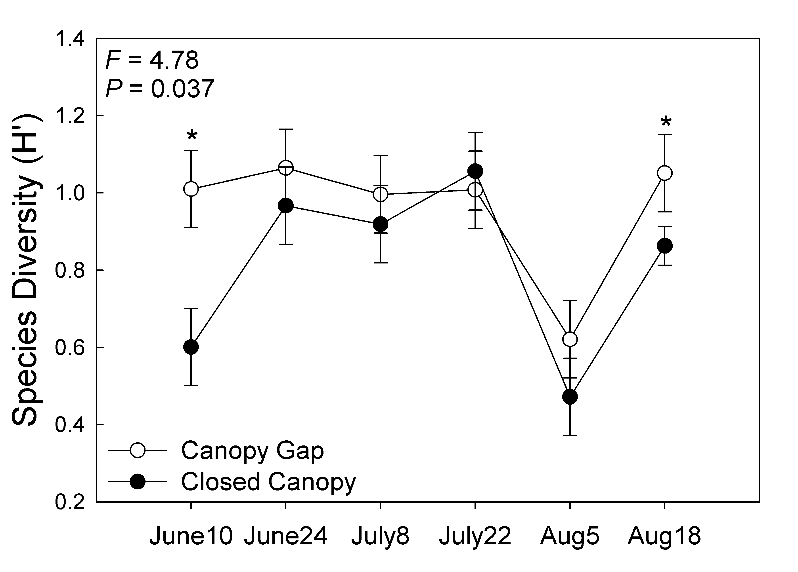

**Figure.** Non-metric multidimensional scaling (NMDS) ordination of ground beetle assemblages in canopy and understory vegetation disturbance treatments using Sørensen’s distance measure. In 2014 (A), assemblage composition differed during the July 1-2 to July 15-17 sampling interval, and the first two axes of the ordination explained 71.4% of the total variation, with *R*2 values of 33.7% and 37.7% for axes 1 and 2, respectively. In 2015 (B), composition differed during the August 5-6 to August 17-18 sampling interval, and the first two axes explained 75.8% of the total variation, with *R*2 values of 42% and 33.8% for axes 1 and 2, respectively. *P* values are given for the multi-response permutation procedure that uses Monte Carlo tests to determine significance.

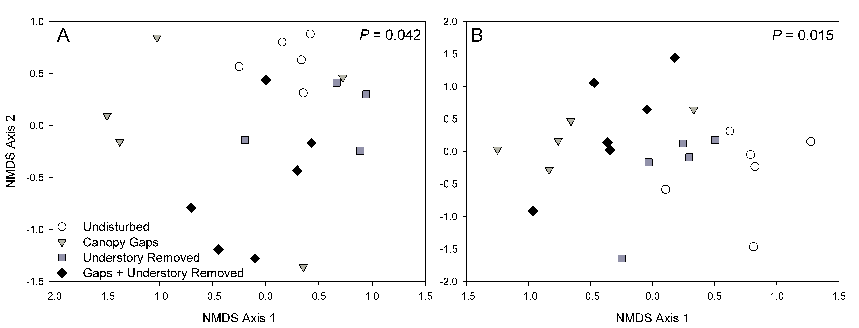

**Figure.** Effects of canopy gaps on the total activity-abundance (mean ± SE) of macropterous (capable of flight) ground beetles at Powdermill Nature Reserve, Rector, Pennsylvania, USA. Results are given for the repeated measures ANOVA, asterisks denote significant differences at alpha = 0.05, Tukey’s pairwise comparisons.

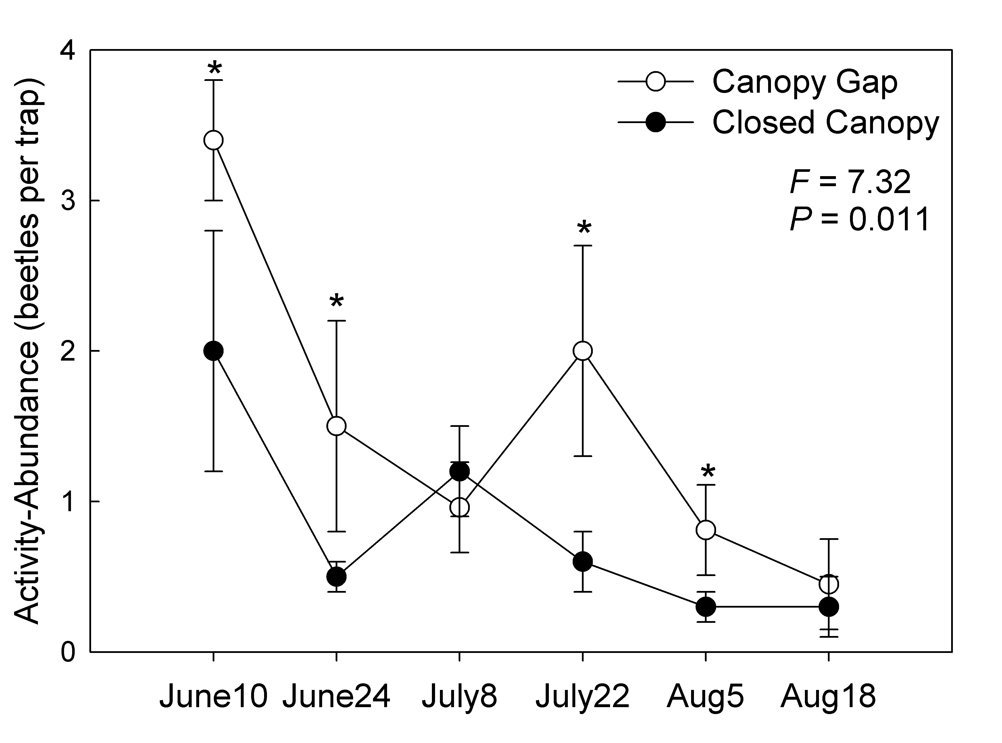

**Figure**. Percentage canopy openness in canopy gap and closed canopy disturbance treatments at Powdermill Nature Reserve, Rector, Pennsylvania, USA. Canopy openness measurements were collected once in 2013 before treatments were implemented. Trees were girdled on June 5-6, 2014, and measurements were collected once per month in 2014 and 2015. Results are given for the repeated measures ANOVA, asterisks denote significant differences at alpha = 0.05, Tukey’s pairwise comparisons.

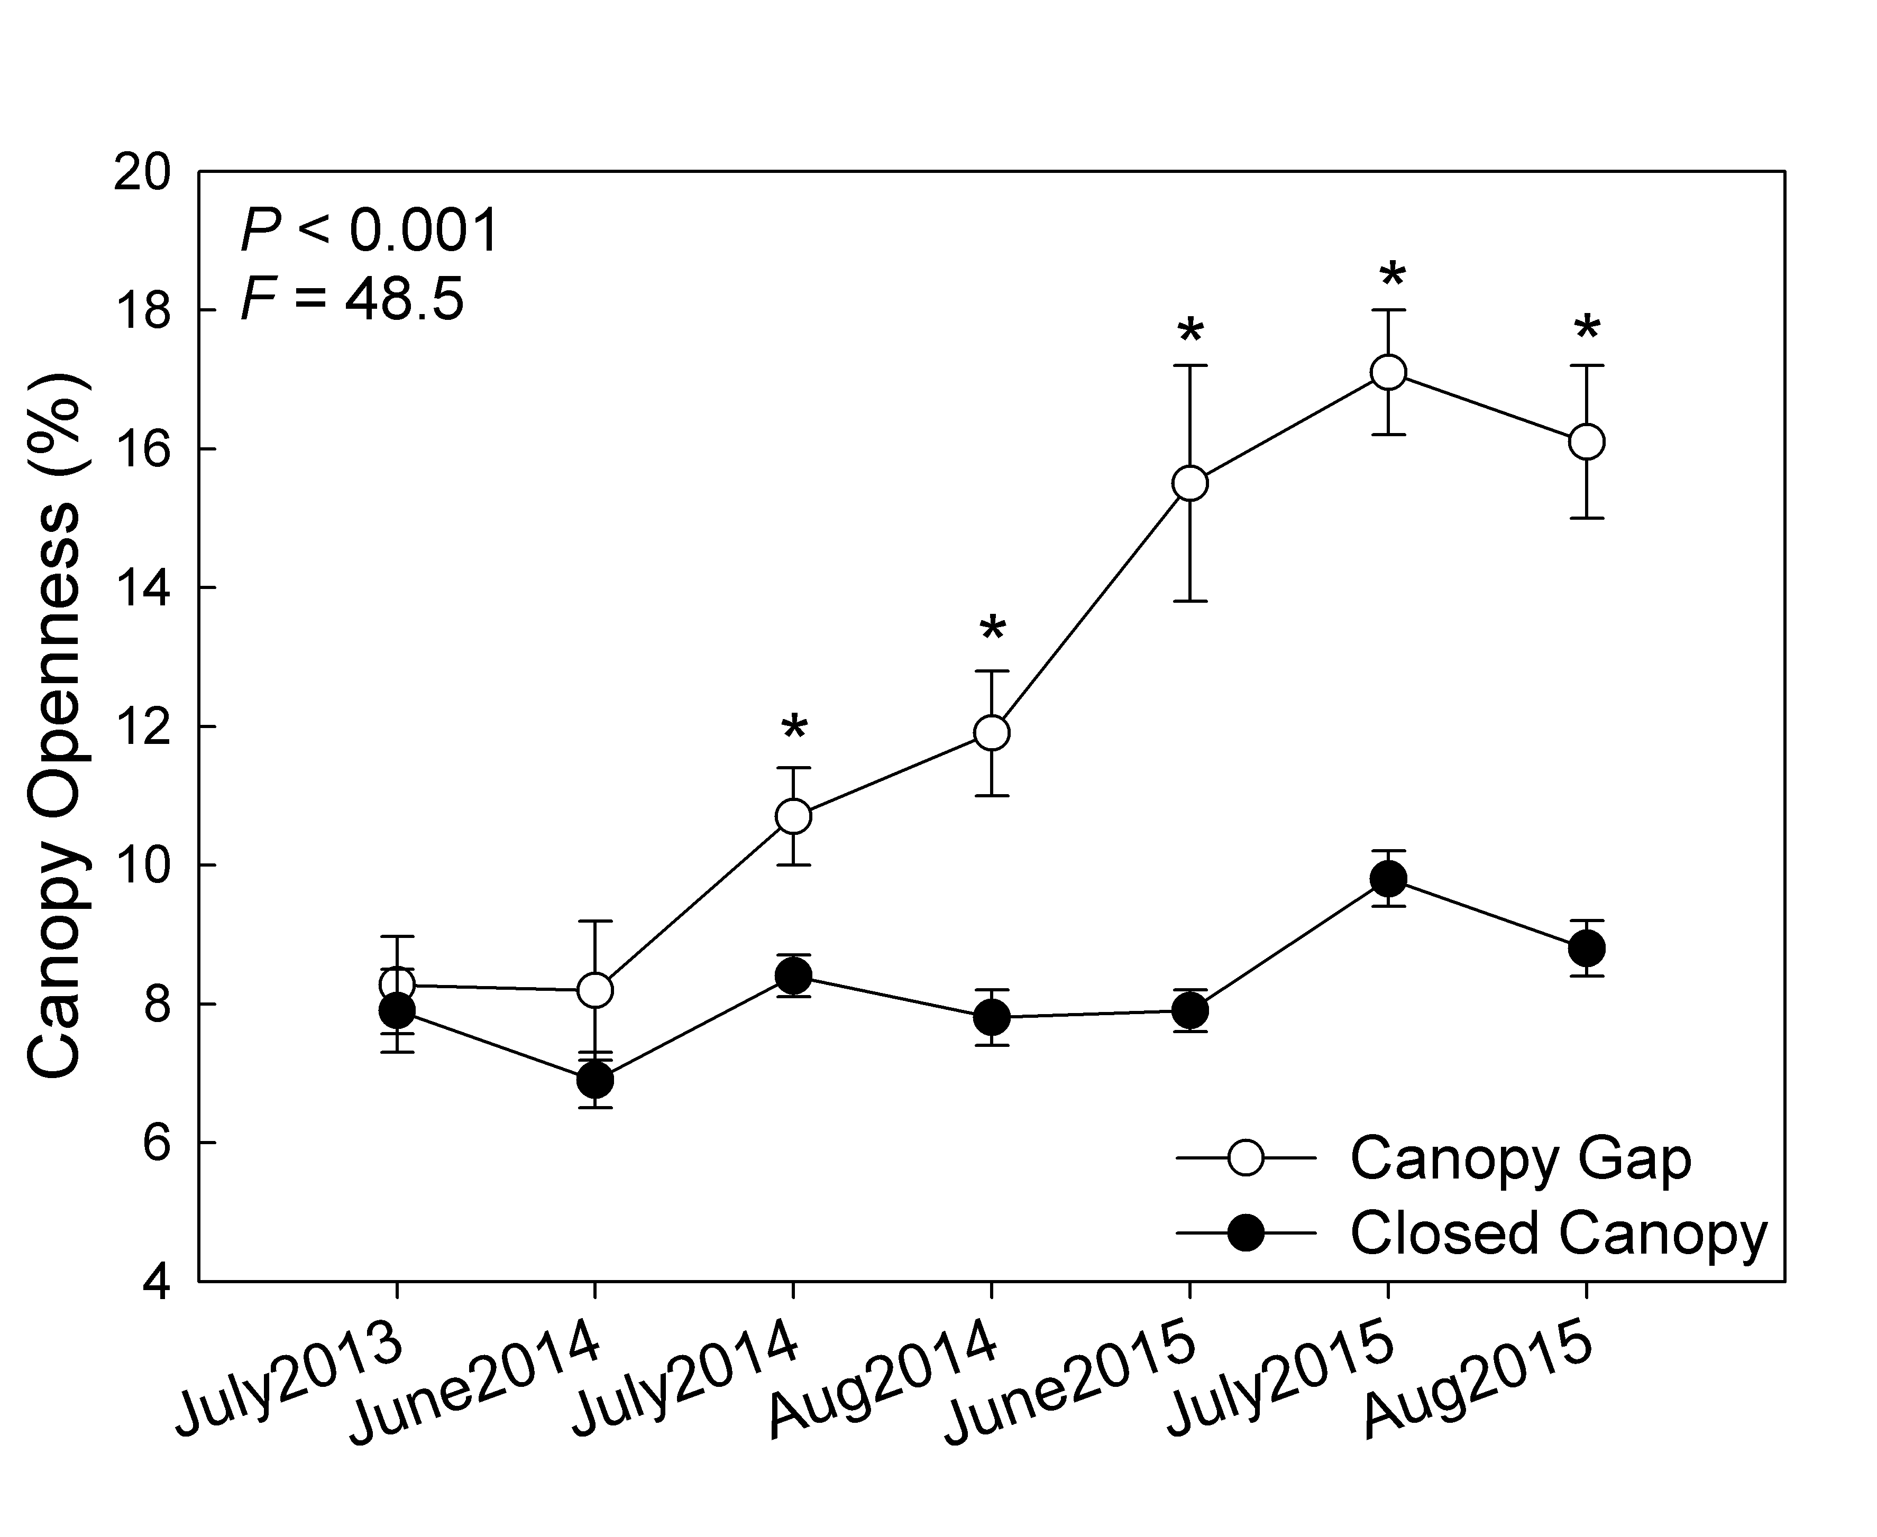

**Figure**. Interaction plots for percentage understory vegetation cover in canopy gap (left) and closed canopy (right) disturbance treatments at Powdermill Nature Reserve, Rector, Pennsylvania, USA. Percentage cover of understory vegetation was measured once in 2013 before treatments were implemented. Understory vegetation was removed on June 5-7, 2014, and vegetation cover was measured once per month in 2014 and 2015. Results are given for the repeated measures ANOVA, asterisks denote significant differences at alpha = 0.05, Tukey’s pairwise comparisons.

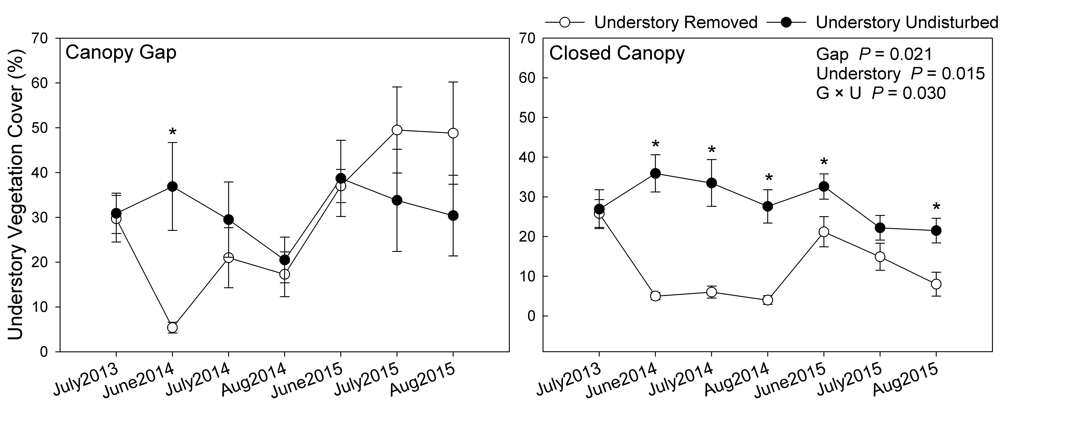

**Figure**. Main effects for canopy decline of girdled trees by species (A) and vasculature structure (B) in canopy gap disturbance treatments at Powdermill Nature Reserve, Rector, Pennsylvania, USA. A 1-5 health rating scale was used to track canopy dieback over the course of the three-year study. A rating of 1 on the scale corresponds to a full healthy canopy; a rating of 5 corresponds to a dead tree; a rating of 2-4 on the scale corresponds to successive stages of canopy thinning. A pre-treatment canopy rating was collected on May 28, 2014. Trees were girdled on June 5-6, 2014. Post-treatment canopy ratings were collected five times in 2014 (June 17, July 1, July 15, August 12 and September 9), and monthly in 2015 (June 10, July 8 and Aug 5). Tree taxa included in the ‘Other’ category were beech, birch, cherry, elm and ash, and only a few trees (1-3) of each species were girdled. Results are given for the repeated measures ANOVA, asterisks denote significant differences at alpha = 0.05, Tukey’s pairwise comparisons.

